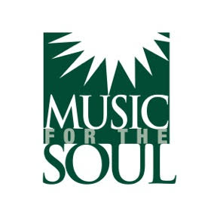

Dear Shelter Owner,

We created the *Love is Just a Wag Away* song and video to celebrate the emotional healing dogs bring. We also hope the song will encourage people who are thinking of getting a dog to consider rescuing a dog from their local shelter.

If you’re a shelter owner who would like to use *Love is Just a Wag Away,* we’d like to offer you a one year gratis (that means *free!*) opportunity to use the song to promote the wonderful work you are doing with your business.

Once you give us your information and sign the license agreement below you can:

* **Show the** **official music video** anywhere (fundraisers, waiting rooms, websites, social media, etc.).
* **Add your shelter’s logo** to the end of the official video if you'd like.
* **Create your own video** using our song. For example:
  + A custom adoption highlight reel
  + A tribute to rescue stories
  + Your own campaign or event promotion

**Just two requirements:**

1. Please include this simple credit in any new video you make with our song:

“The song Love is Just a Wag Away courtesy of [www.musicforthesoul.org](http://www.musicforthesoul.org)”

2. Sign and return a copy of this agreement so we know who’s using the song

**One-Year Term, Optional Renewal**

This agreement is **completely free for one year**. At the end of the first year, you will have the option to renew the license for a fee of $100.00 if so desired.

Ninety Forty Ten is the publishing company of Music for the Soul and owns the rights to *Love is Just a Wag Away.* Clear Box Rights is the administrator for the catalog and has provided the license agreement below. Please fill in your shelter company information at the top and sign and date at the bottom.

Then e-mail it to us at [info@musicforthesoul.org](mailto:info@musicforthesoul.org)